ARCOLA HERE WE COME!

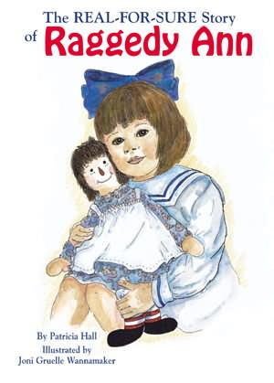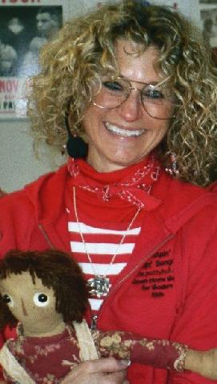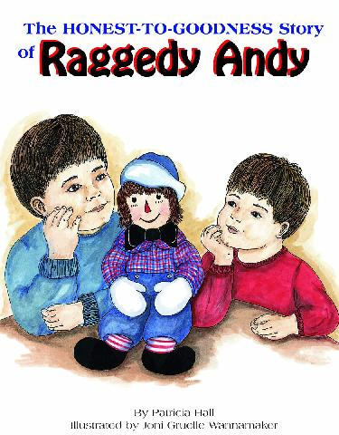

16th ANNUAL RAGGEDY ANN & ANDY FESTIVAL

ARCOLA, ILLINOIS

FRIDAY- SATURDAY-SUNDAY

May 20-21-22, 2005

Join PATTY at the 2005 Raggedy Festival for BOOK SIGNINGS with JONI GRUELLE WANNAMAKER, MUSICAL PERFORMANCES, and her SALES BOOTH.

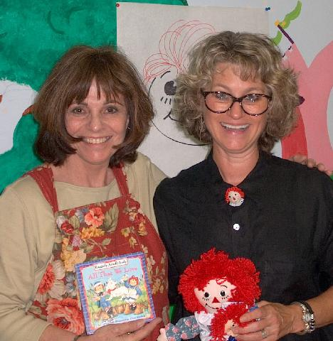

BOOK SIGNINGS
WITH JONI

GRUELLE RAGGEDY MUSEUM
Saturday – 11 AM

PATTY’S BOOTH – ARCOLA CENTER
Saturday – 1 PM
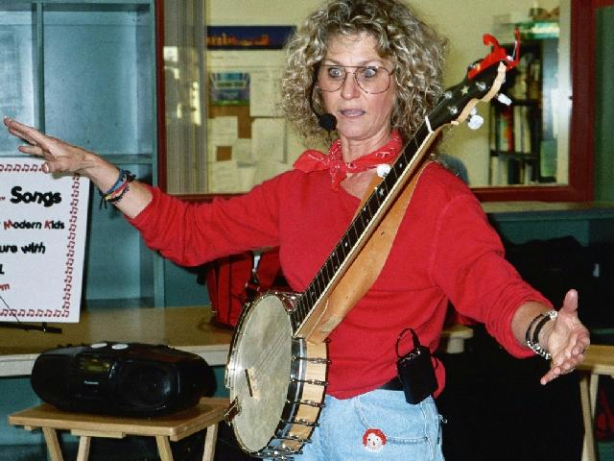

RAGGEDY ANN & ANDY
JUMPIN’ UP!™ SONGS

HOSPITALITY TENT
Sunday - 1:00 PM
Come JUMP’ UP!™
with Patty in this musical show for families -- and don’t forget to wear your JUMPIN’ UP!™ shoes!
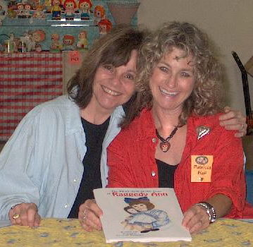

SALES & EXHIBIT BOOTH

ARCOLA CENTER
Saturday – 9 AM- 5 PM
Sunday – 9 AM – 4 PM

Stop for a visit with Patty and to pick up autographed copies of her books and tapes.

VISIT PATTY AT www.pattyhall.com
VISIT JONI AT www.raggedyann-museum.org

